Searching and applying for new job in CUTM has now become easy task with https://career.cutm.ac.in/ . Those who want to join to Centurion University as Teaching or Non-Teaching job they can apply now through this “CUTMcareer“ portal. It will provide user interface where candidate can apply for new job and viewed applied history.

**User:** - This web portal gives access to two kinds of users.

1. Administrator : the admin have access to check how many candidate applied for jobs along with candidate details, like resume, Certificate etc.
2. Candidate :- The candidate is the user who applied for job. The candidate have to register and then apply for job. The candidate also view the history and job status(pending, approved or rejected) .

User Interface :-

1. **Index.php-** 1st the candidate have to register before applying for a job. For registering the candidate have to provide Full Name, email, Password and a profile picture.

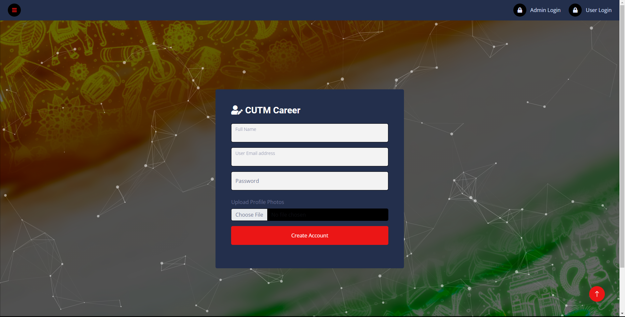

1. **userlogin.php-** Now the user login to portal using registered email and password.

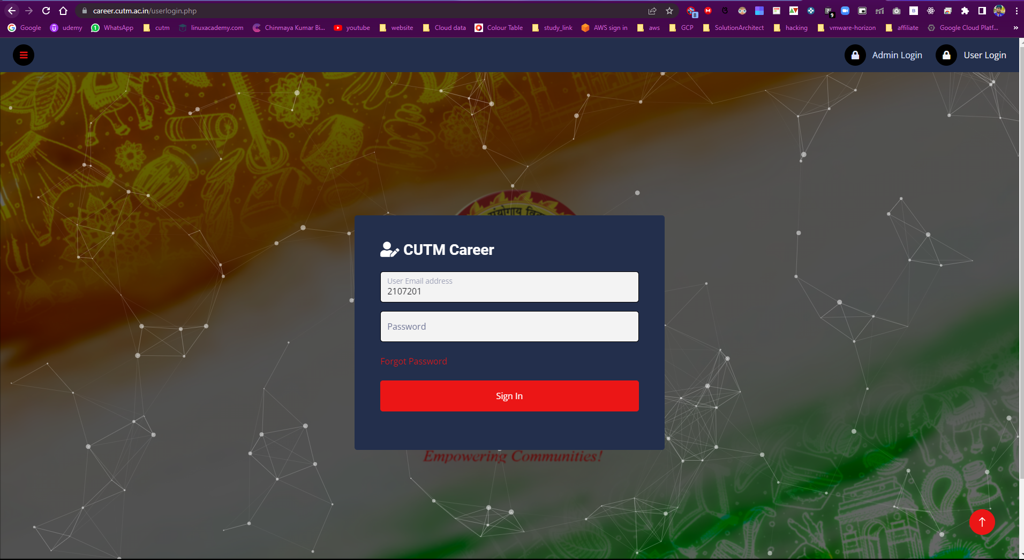

1. **userDashboard** – In user dashboard the user view applied job history and Application status.

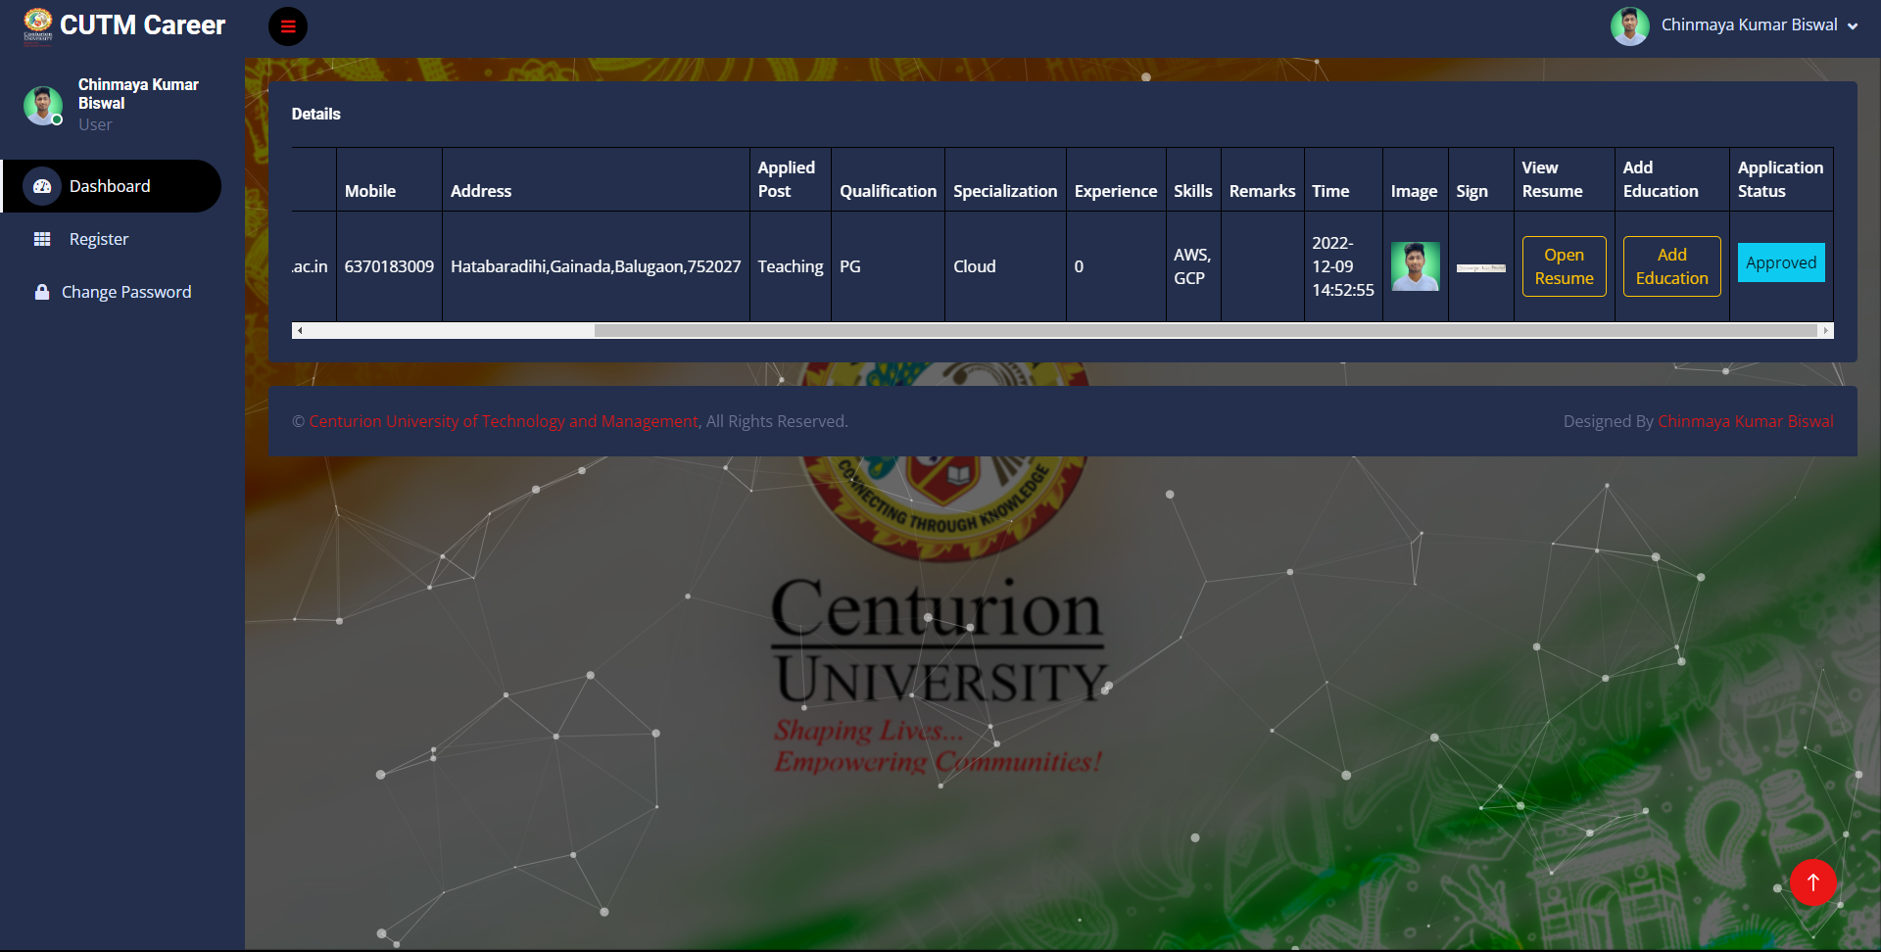

1. **registerme.php-** Here the candidate should fill up the form to applied for job here the user have to upload the resume and digital signature and the resume only accept pdf format maximum size 50MB. Then Click on register then it will redirect to another page for moredetails.

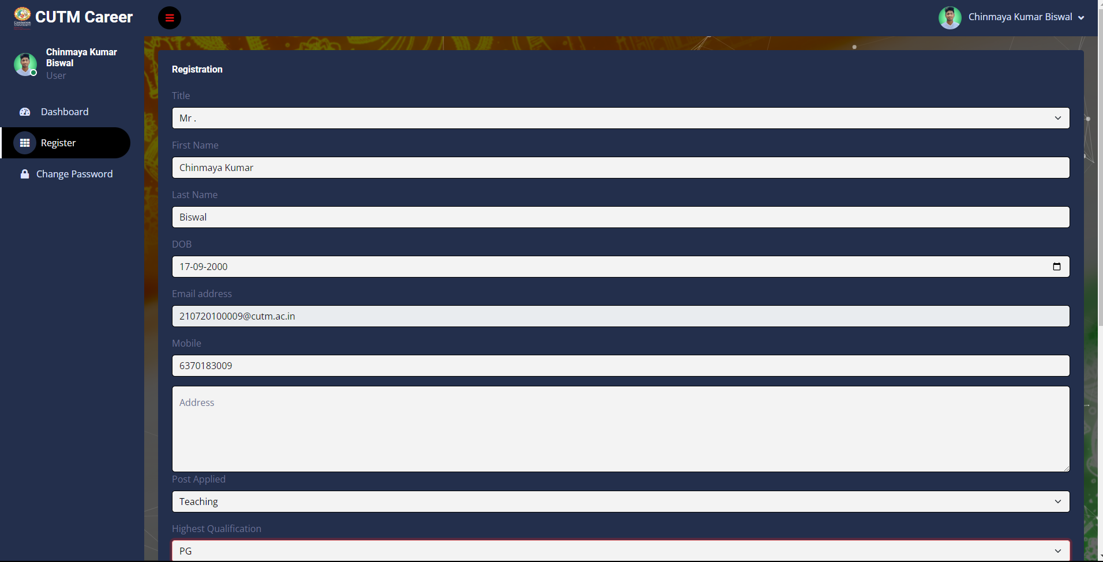

1. **educationDetails.php-** in this page the candidate have to update their education details and upload there certificate soft copy .

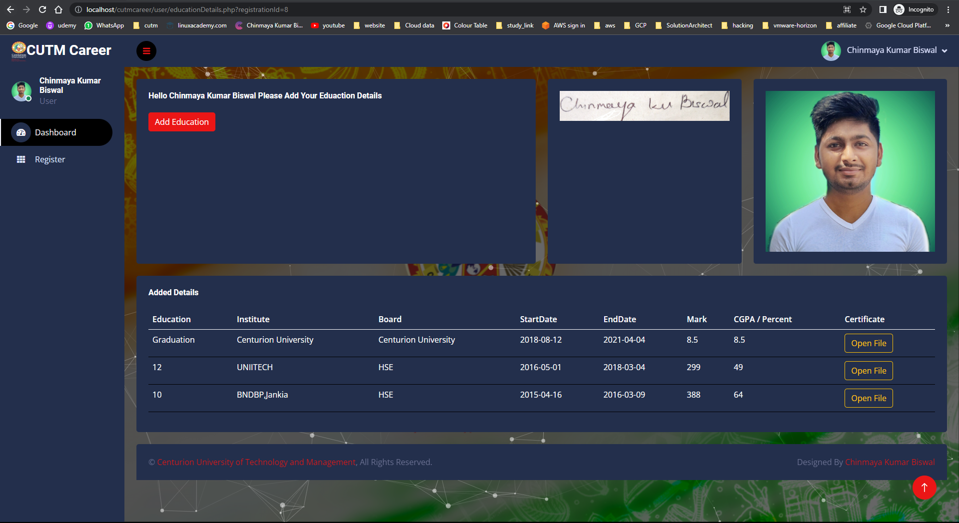

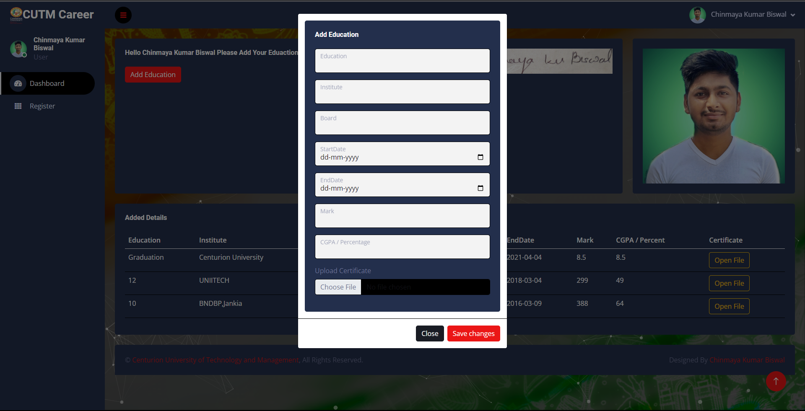

1. **changePassword.php-** in case the user wants to reset password they can reset it.

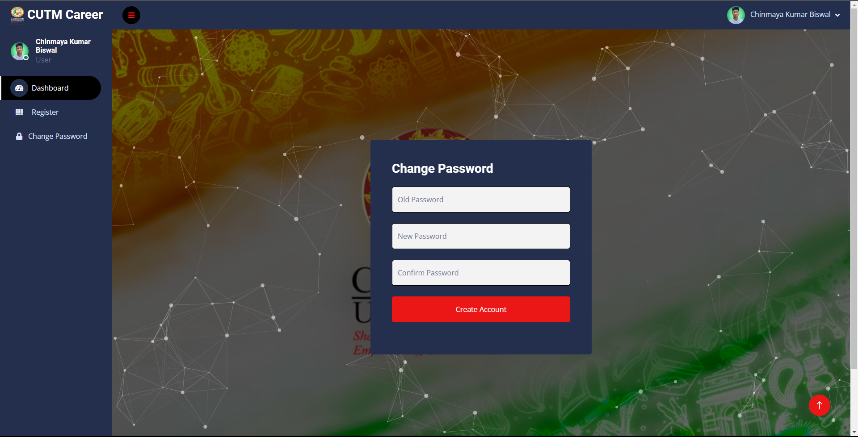

1. **adminlogin.php –** now admin login the portal using this.

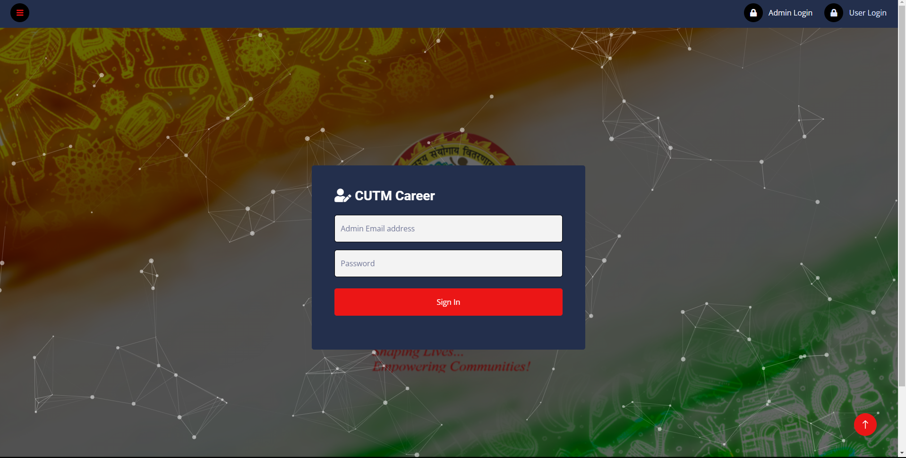

8.adminlogin – This is the admin dashboard. Here admin view how many candidate have applied for jobs. The admin also reject the application or approve the application.

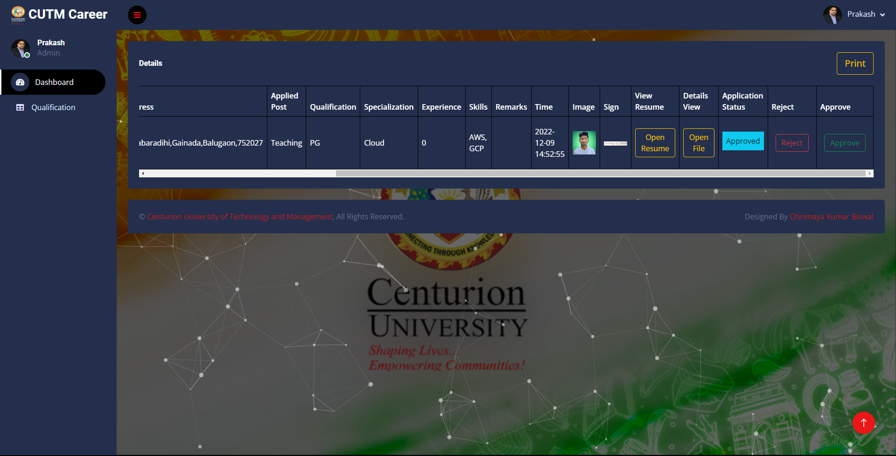

1. **educationDetails.php(admin)** – here admin view the education details of candidate .

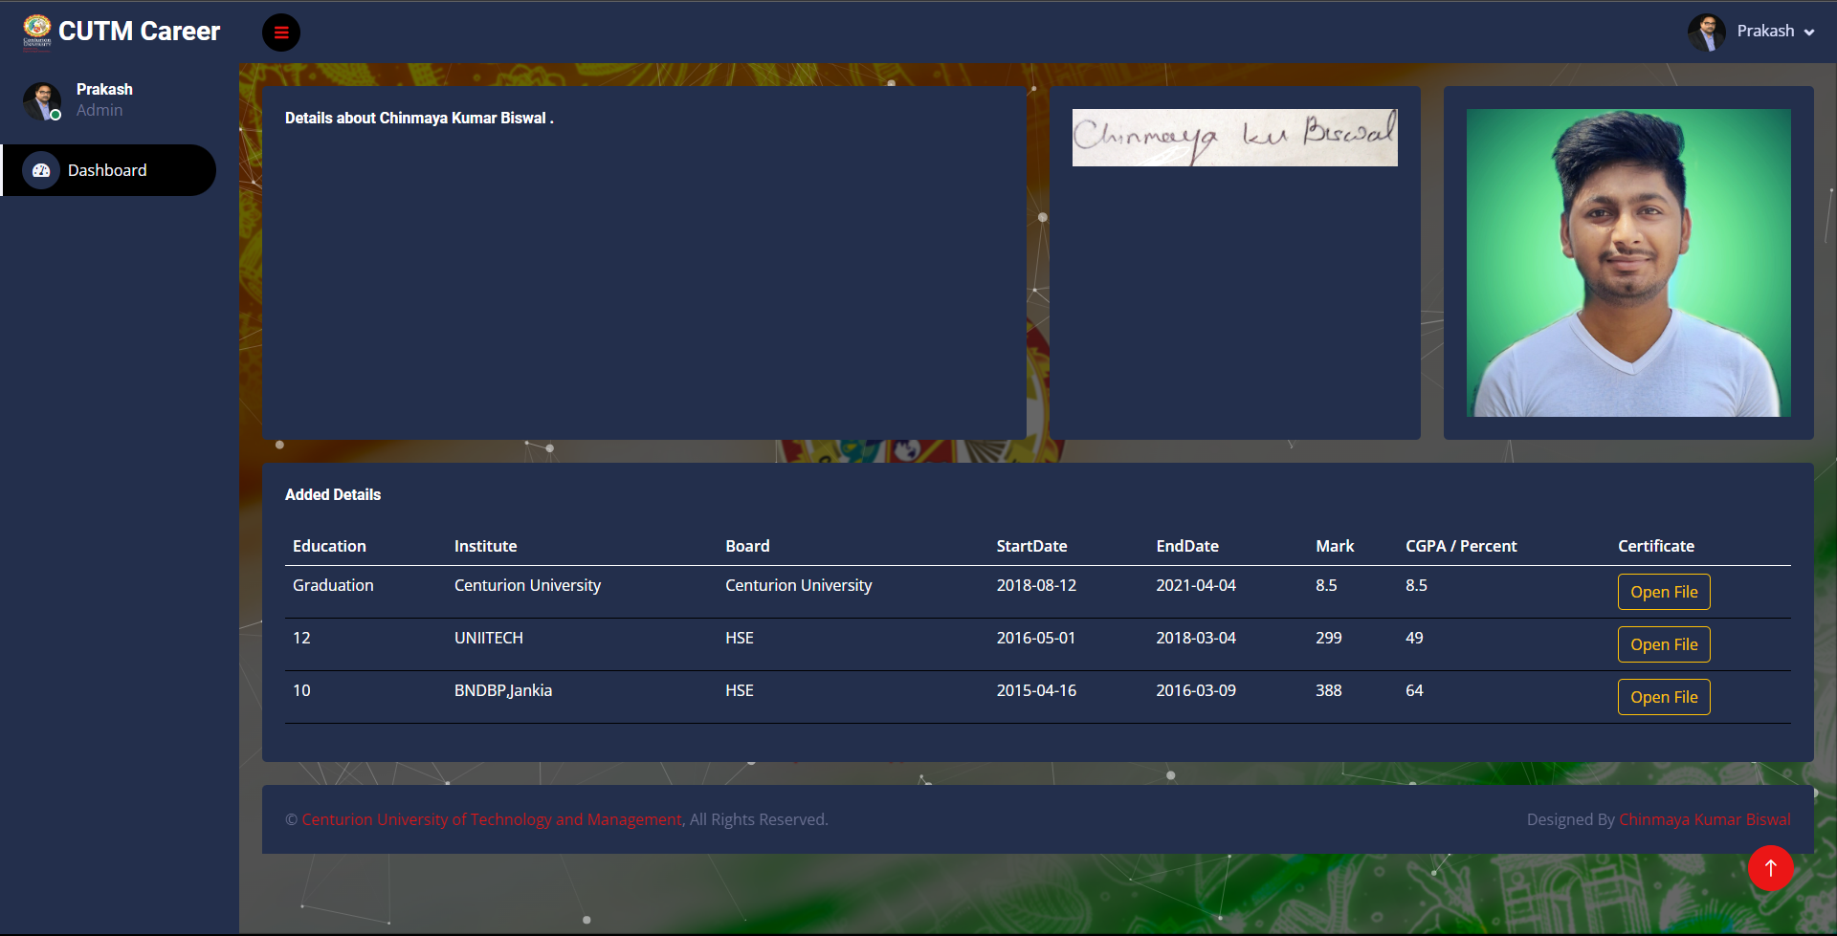

1. **qualification.php –** The admin here filter the applied candidate qualification wise. And export the details in excel format.

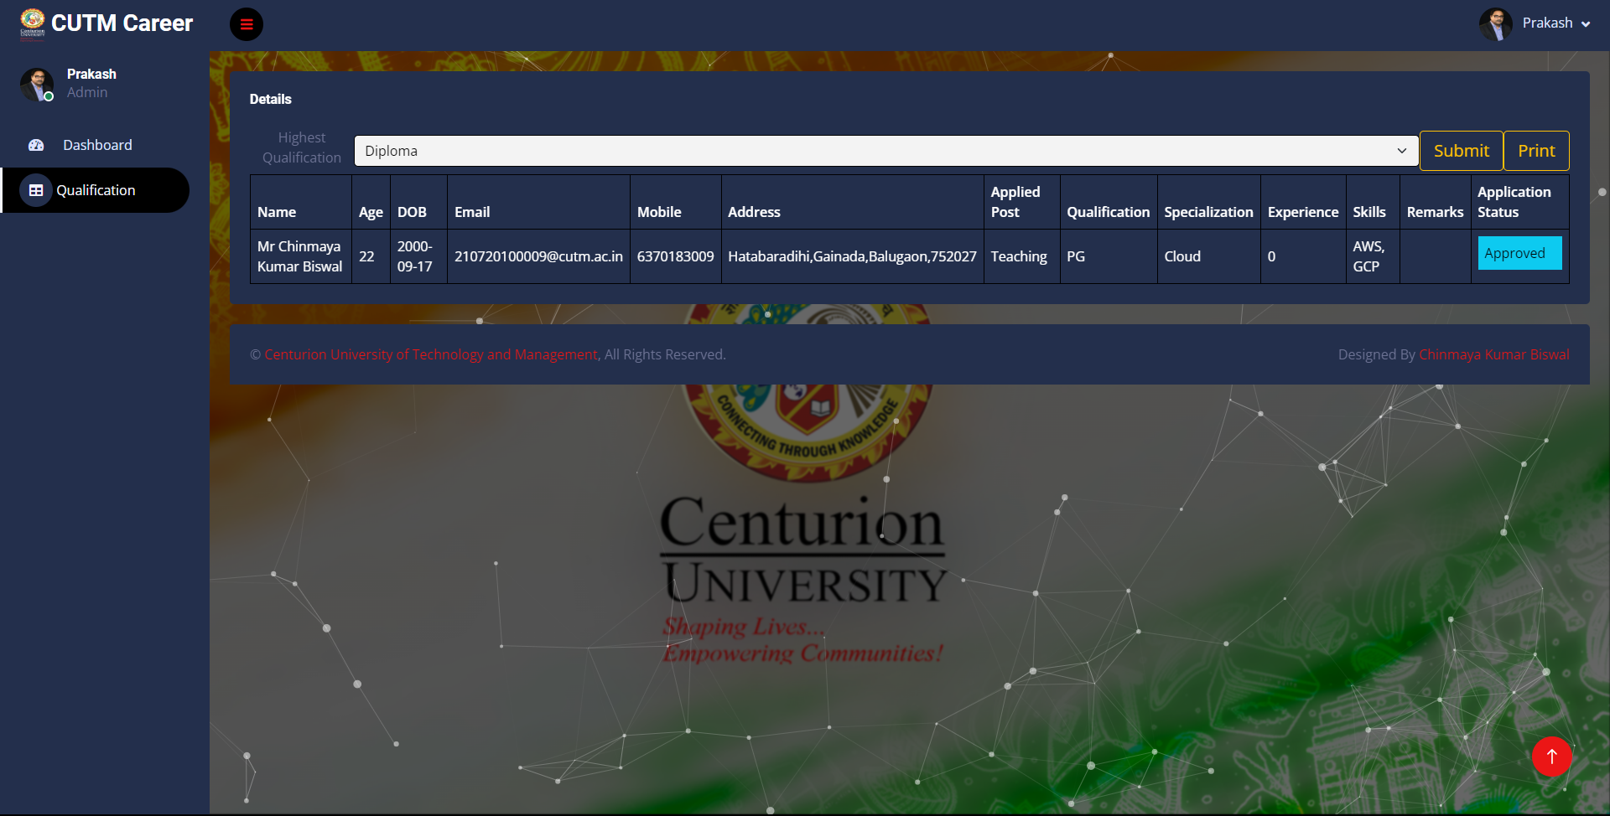

**Tools and Library –**

1. HTML
2. CSS
3. Bootstrap
4. Jquery
5. Particles js
6. PHP
7. JS
8. Ajax
9. Ajax(xlsx-lib)
10. SMTP(PHP mailer)
11. MD5

GitHub - <https://github.com/chinmayakumarbiswal/cutmcareer.git>

**Team-**

Chinmaya Kumar Biswal

210720100009